Introduction

A hotel in the city Centre named as City Central Hostel which has been bought by a new company and the company wants to modernization the rooms and new facility to the customer. To implement this, they have plan to implement a computer network and information system in order to ensure that all data processing is which includes guest data, payments, booking, cancellations and also staff data their wages as well as catering supplier’s data and payment. And administration tasks such as issuing of invoices, the production of emails, letters and creation of advertising documents and social media content.

Task 1 – Application Software and business processes

a)

Database Management software

The DBMS supports by providing the following supports to the Hotel:

* DBMS stores the data in systematic and organized way.
* DBMS can store a large amount of data in a single software.
* DBMS will help in increasing the efficiency of the business operation.
* DBMS provides a highly efficient method to handle multiples type of data.
* It supports multiple users uses same system at the same time.
* Data are easily managed and handles in the DBMS
* The data in the software are search in a better manner.

b)

The different types of the application software that could be used in the hotel for the administration task are:

1. Multimedia:

* Used to grow the business.
* It is used for the generating of the advertisement tools.

1. Spreadsheet Software:

* It is used for generating bills.
* Storing the data of the staff and customer such as payments.

1. Email programs

* This is mainly used for sending and receiving of the email.

1. Words processing software:

* It can be used for the creating of the offer letters
* To create faxes and documents.

1. Presentation Software

* Used to present the graphs of the development of the Hotel.
* Display the information to the owner

c)

The CEO must ensure following

* Is the software being stable and reliable to the hotel.
* How many features the software contains.
* How much customer friendly is the software company.
* How easy is it to learn and use?
* Is the price of the software being good?
* What the people are saying about the software.
* Security Element
* Scalability

Is the software being able to full fill the needs of the business

Task 2:

* The software will exactly be developed for the fulfillment of the needs of the end user
* For the accomplish a specific task a single software would be developed.
* Chance of threat and virus are less in the application software.
* It can be updated as user requirement.
* Correction of the problem that may be a arise.
* Takes less time to perform various task.
* Reduces the human resources.
* Increases the profit of the company.
* Improves the efficiency of the work by eliminating human errors.

Simple to install

Well the Installation should be simple and well documented as it is the first thing that is the point of contact for user so it should be user friendly. If the installation becomes complicated the user will goes on the next application.

Easy to update

The updating process of the of an application should be easy and if they are complex user will skip the process. Without updating a software, the software becomes less reliable.

Efficient

Not only

Pleasant

Easy to remove

Easy to troubleshoot

Doesn’t need third party software

Effective error handling

Task 3:

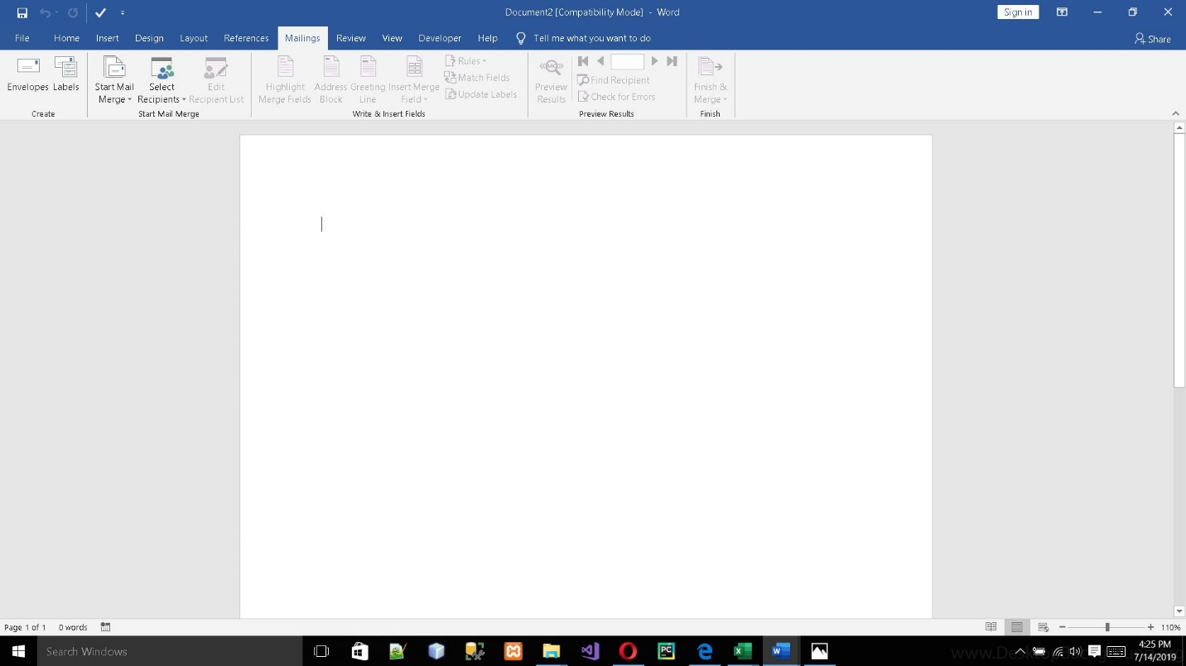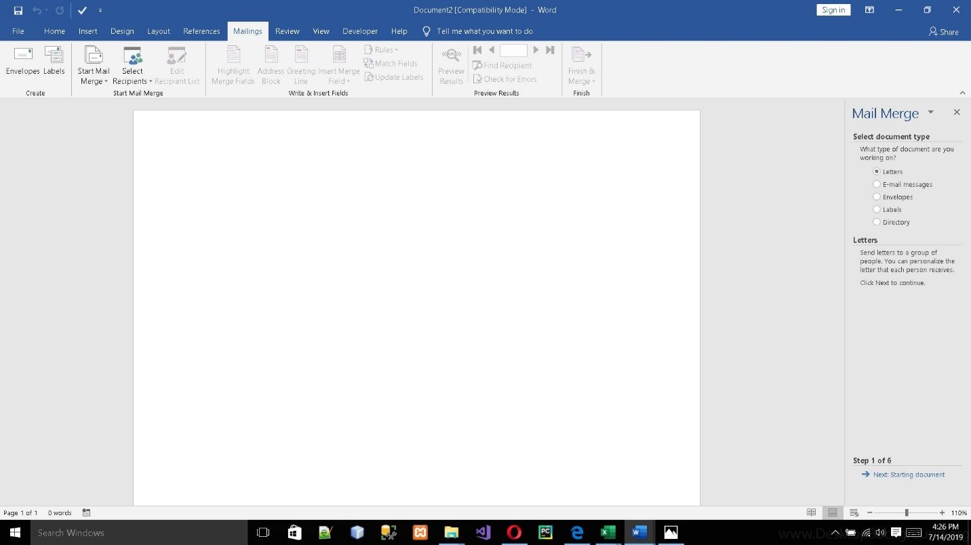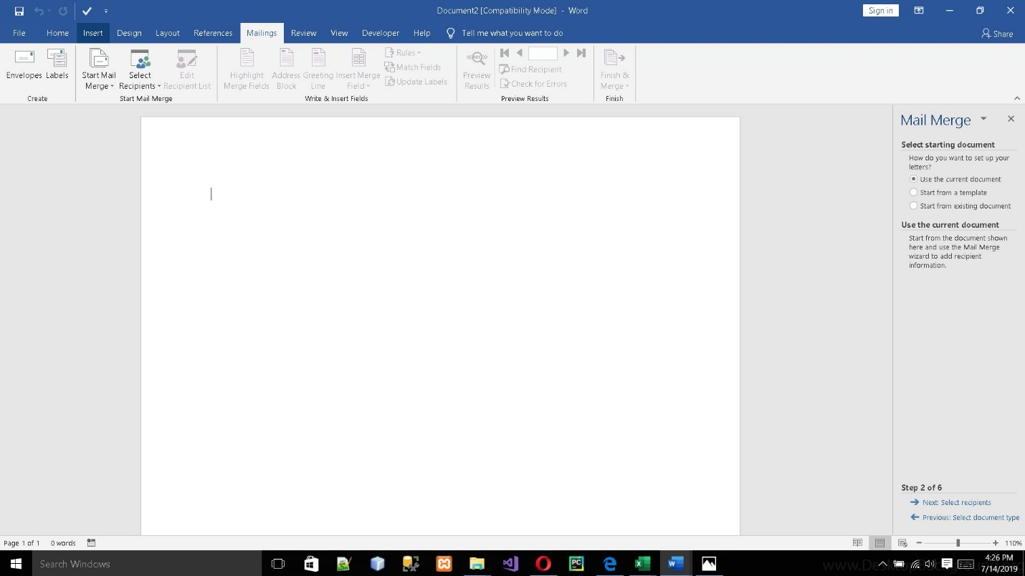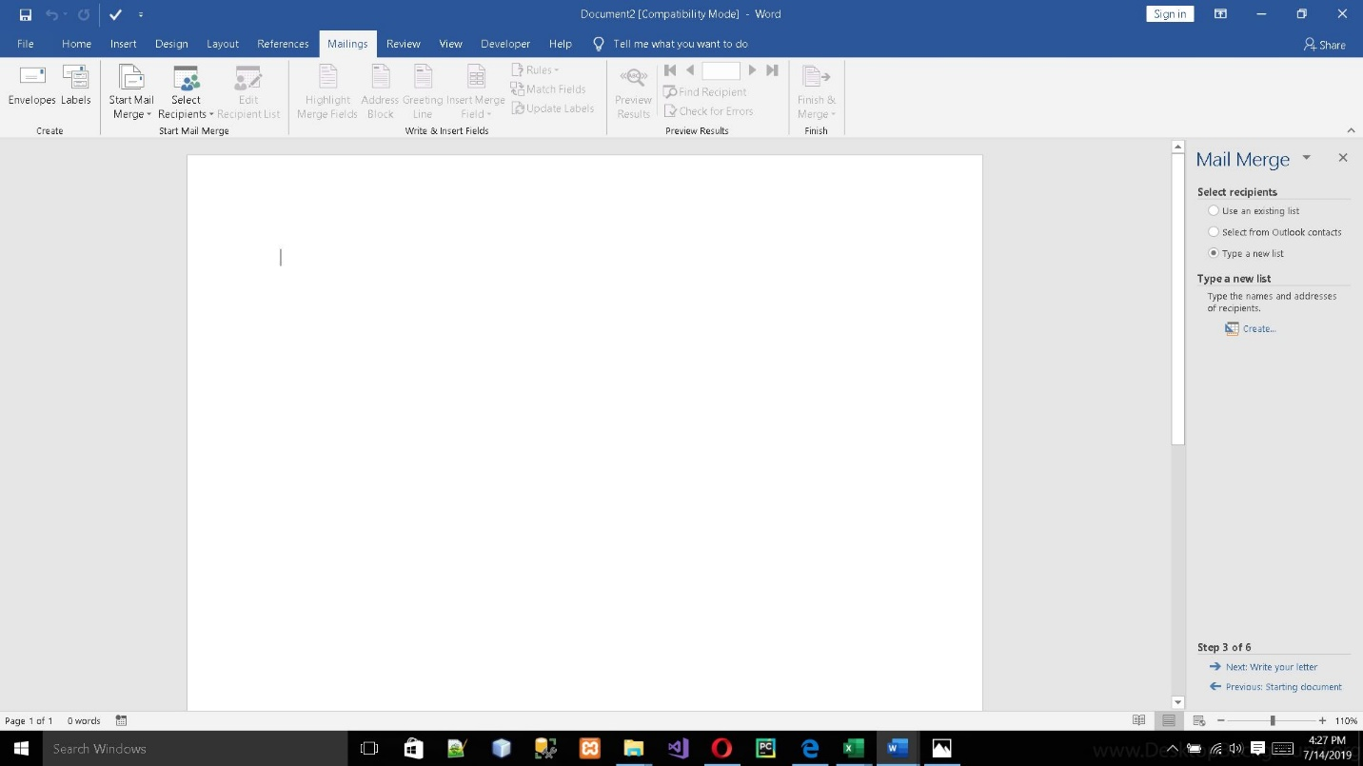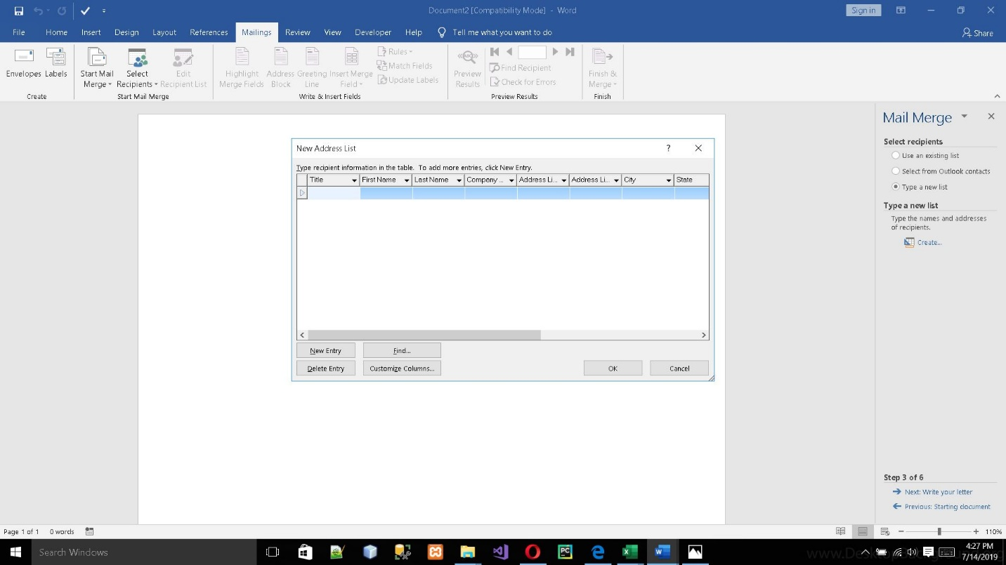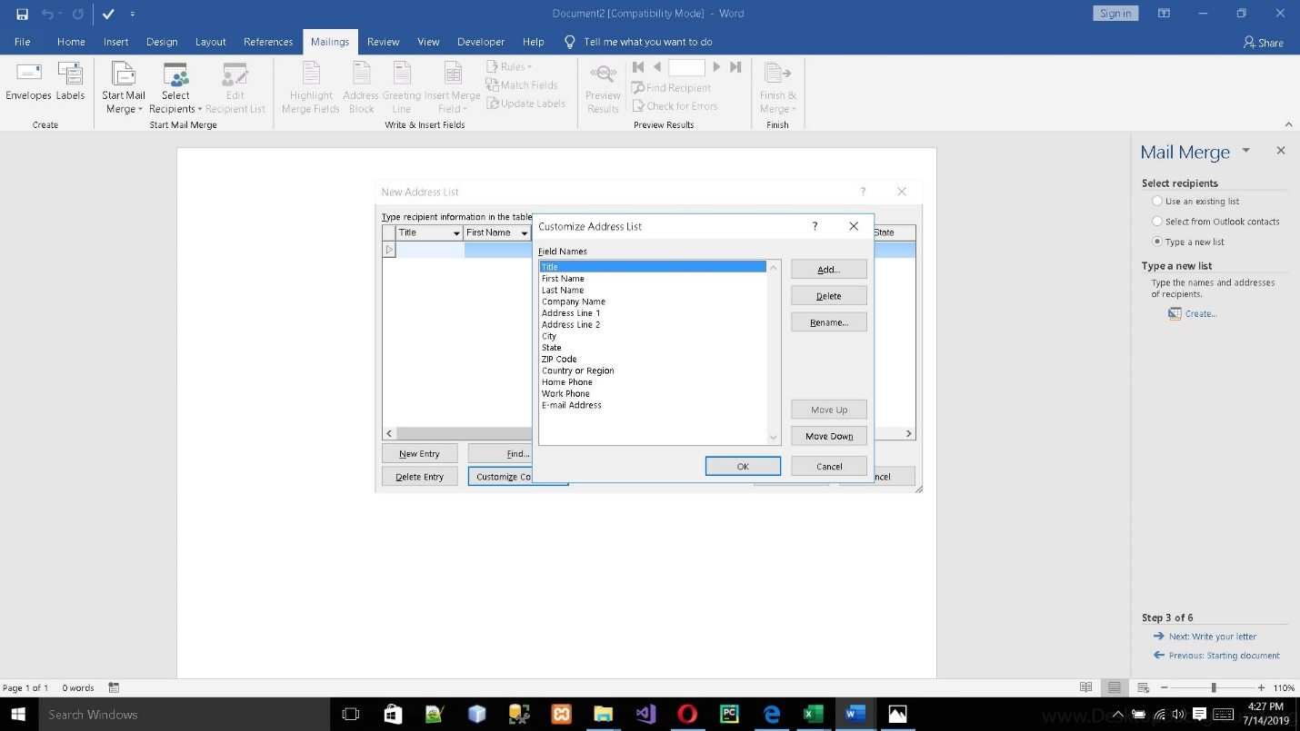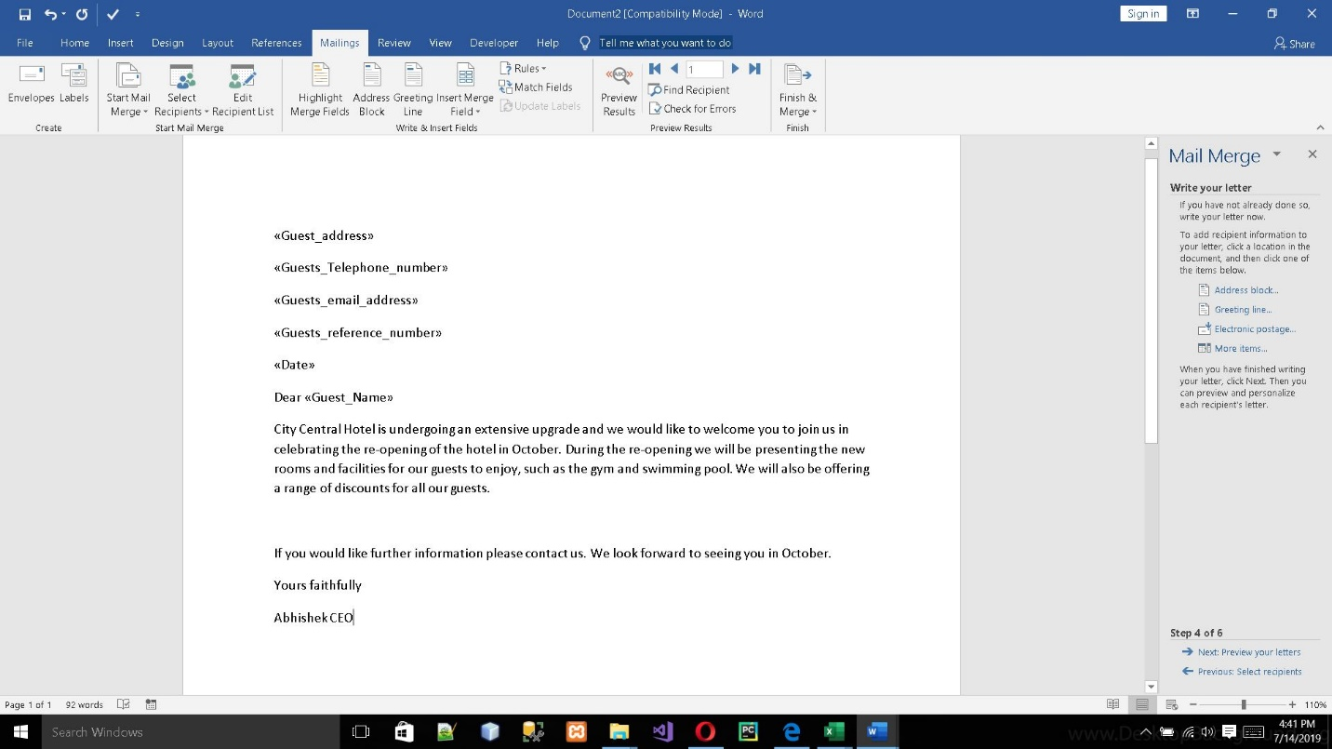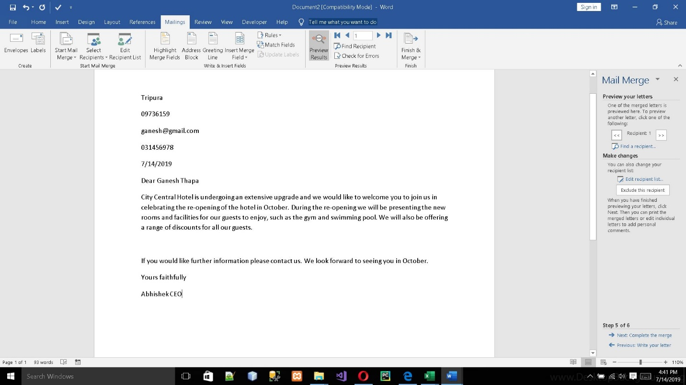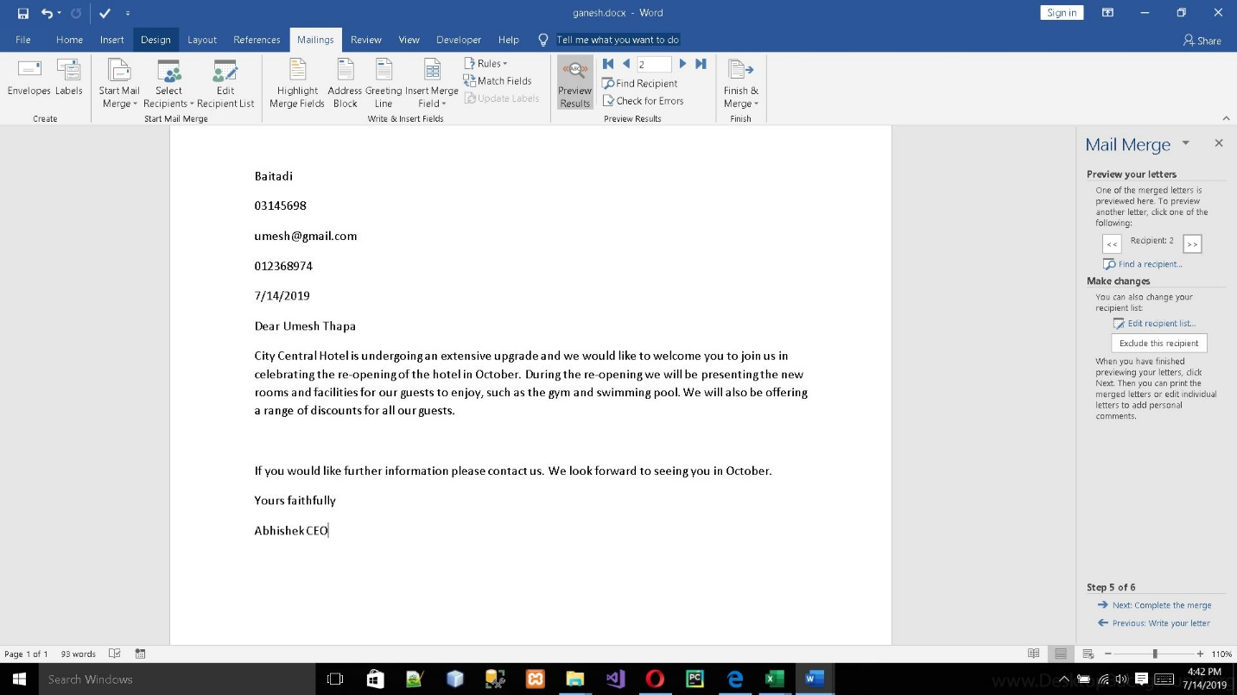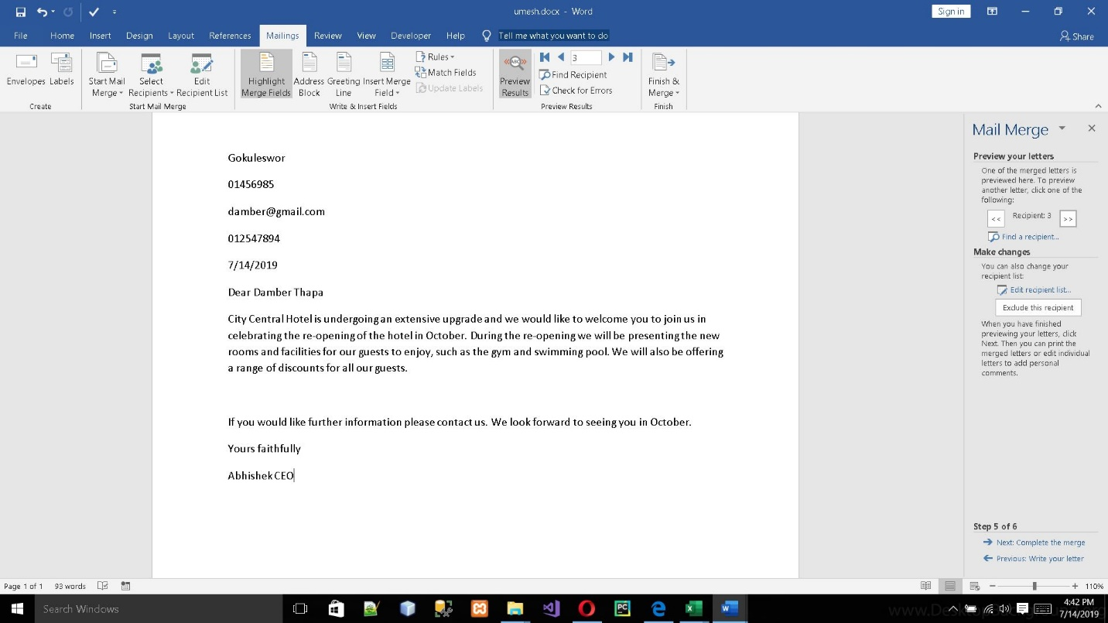

Task 4:

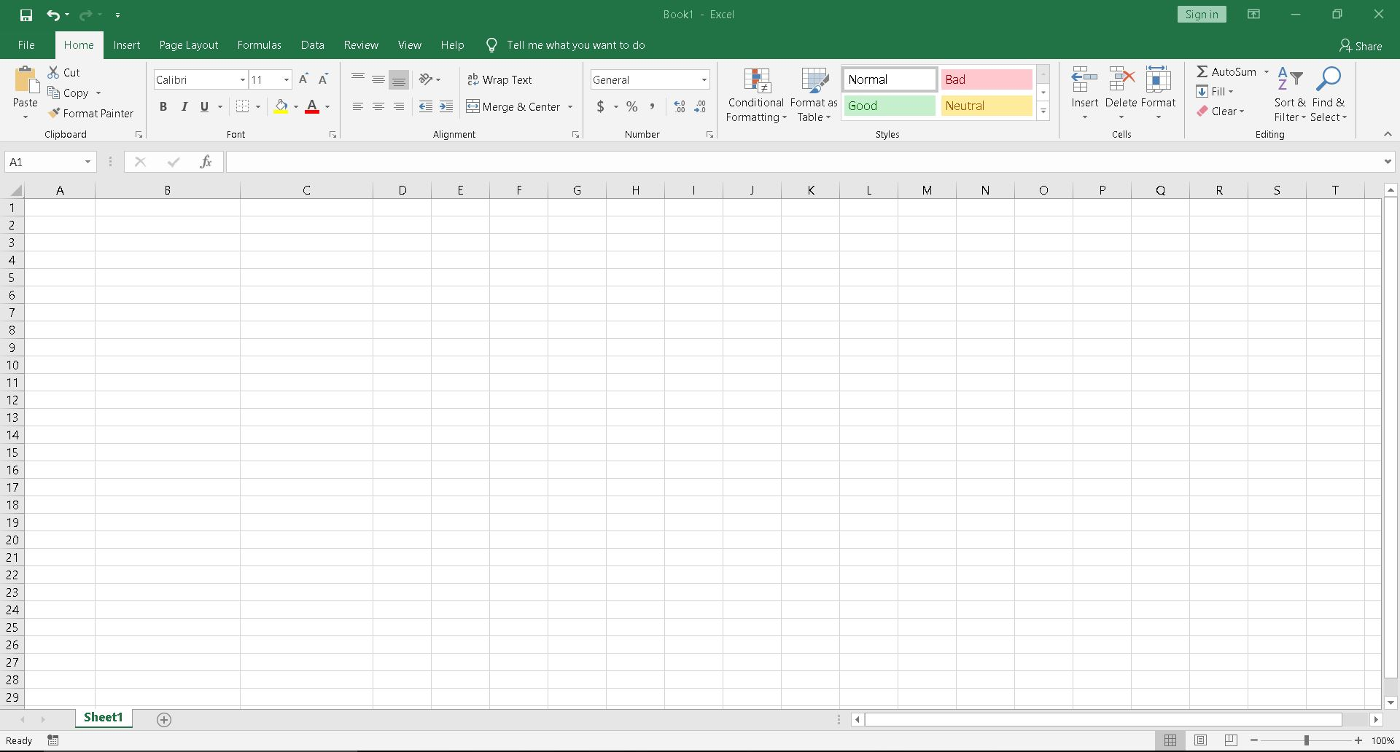

Figure : Excel Home Page

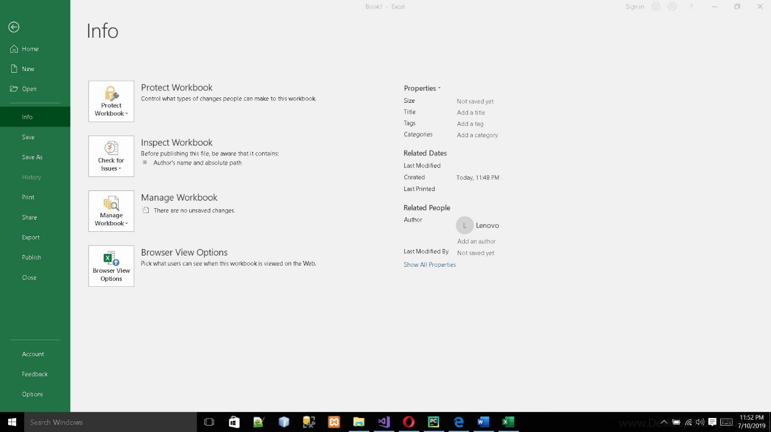

Figure : Menu Bar

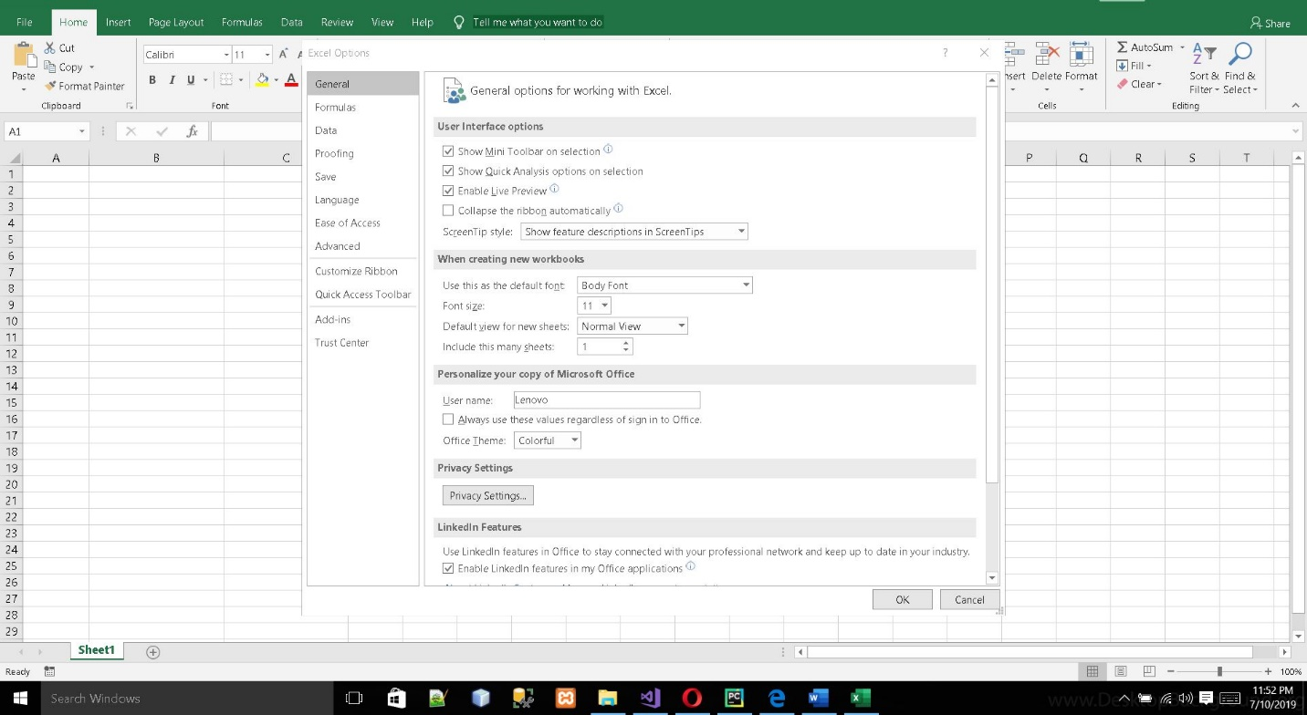

Figure : Option Menu

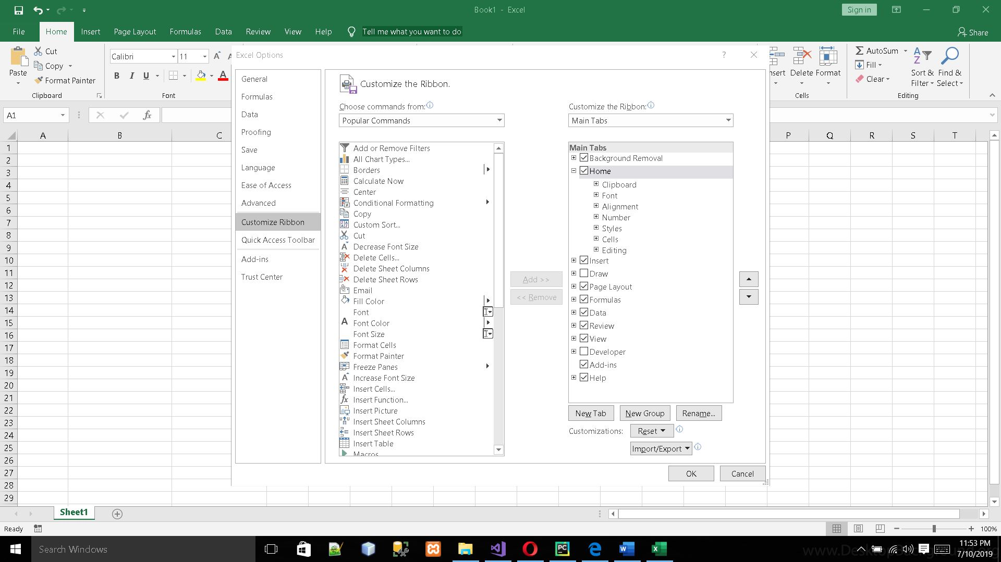

Figure : Selection of Developer Option

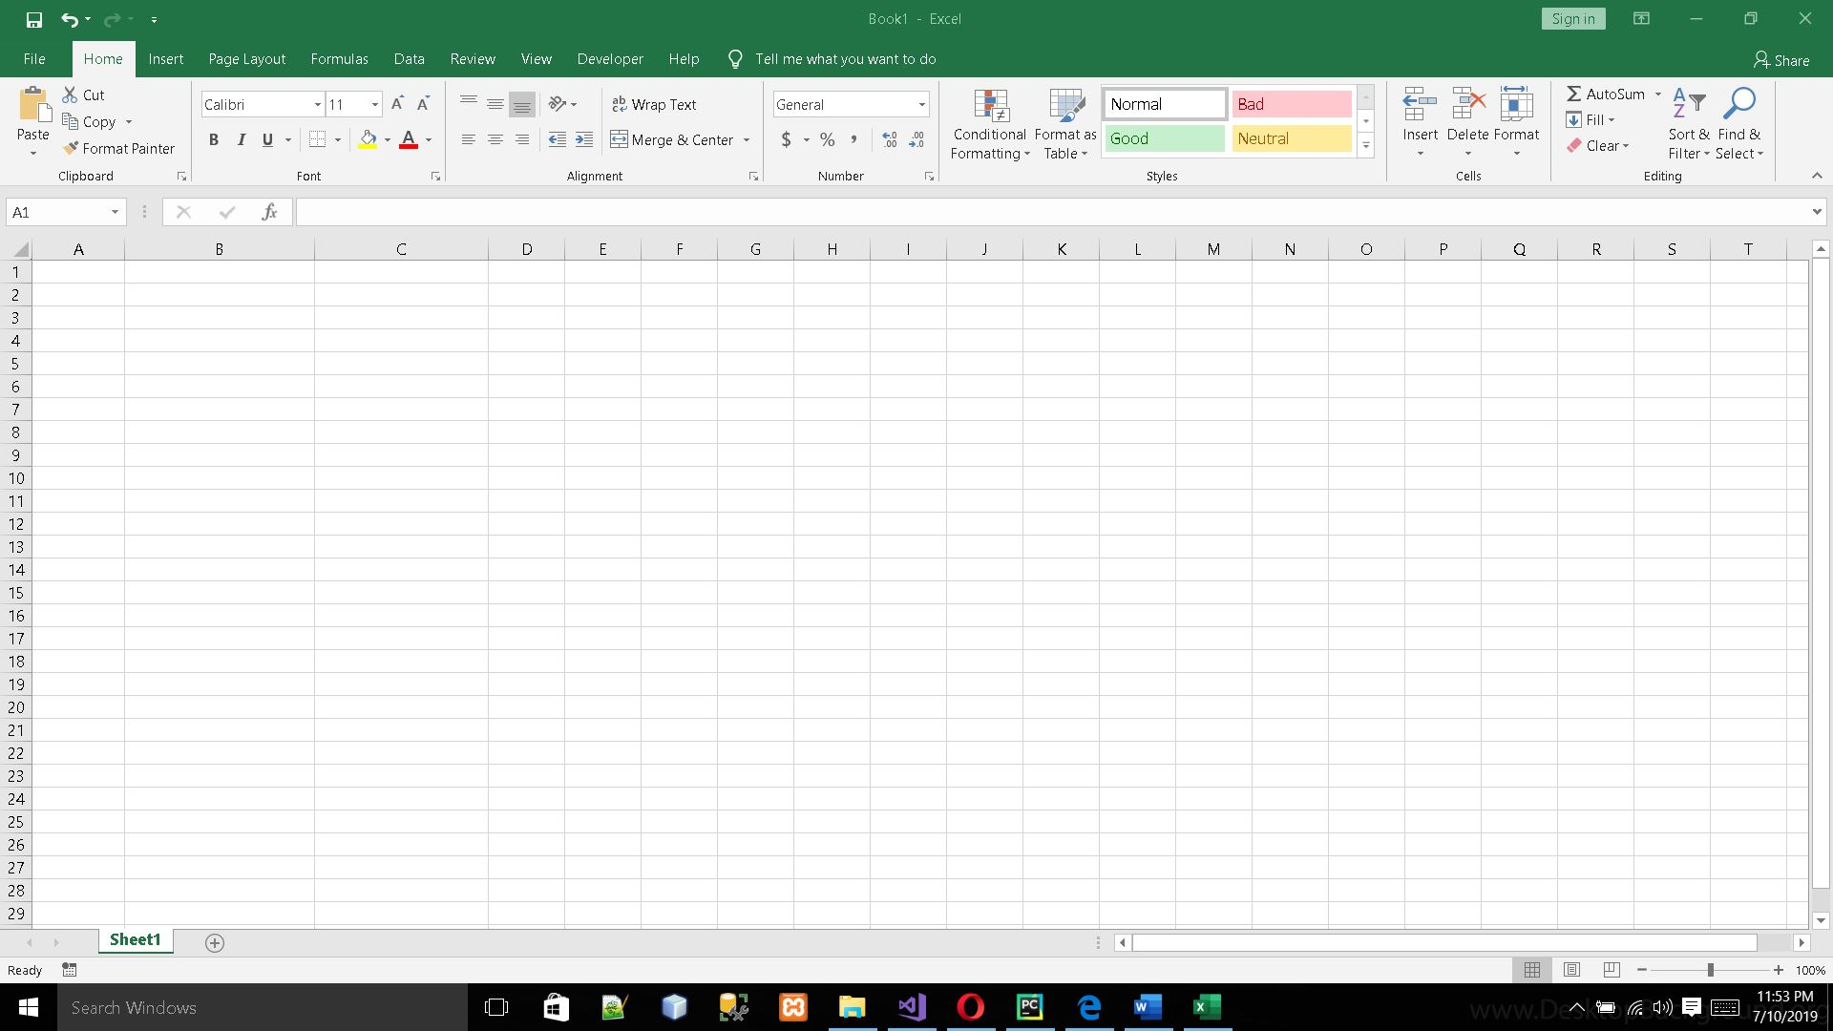

Figure : Home Page with Developer Option

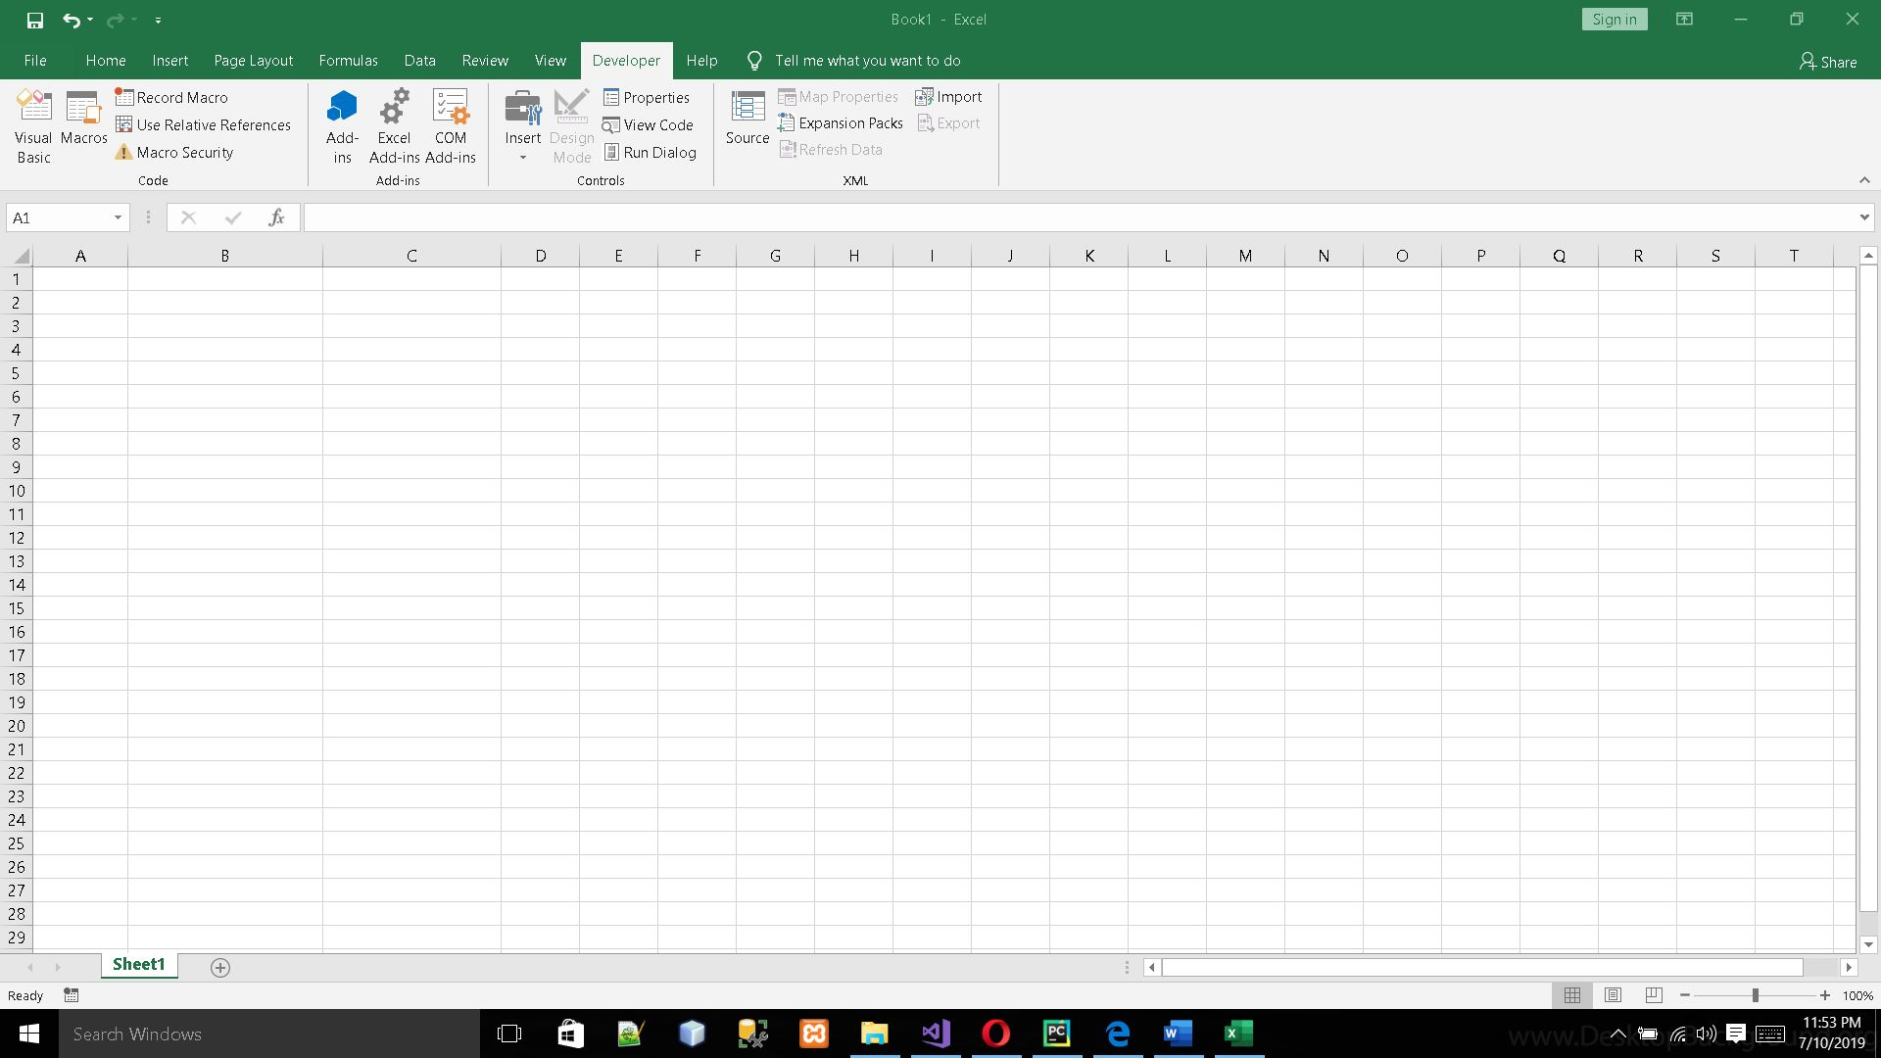

Figure : Visual Basic

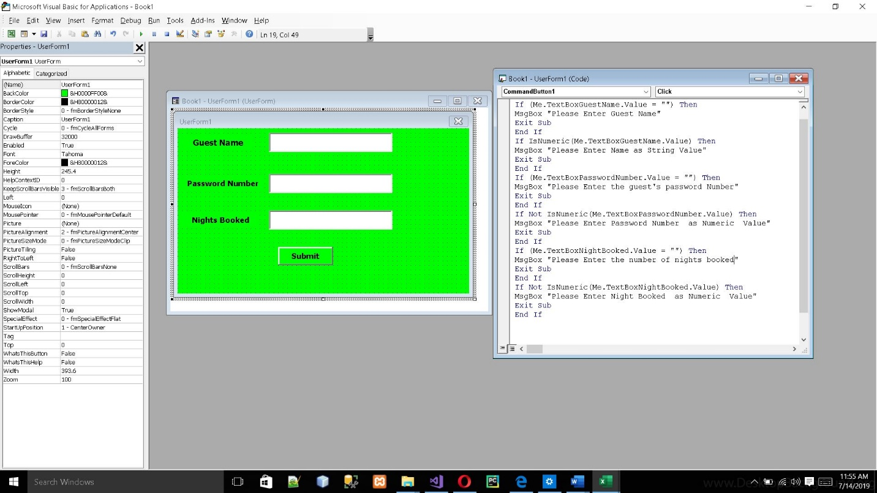

Figure : Coding

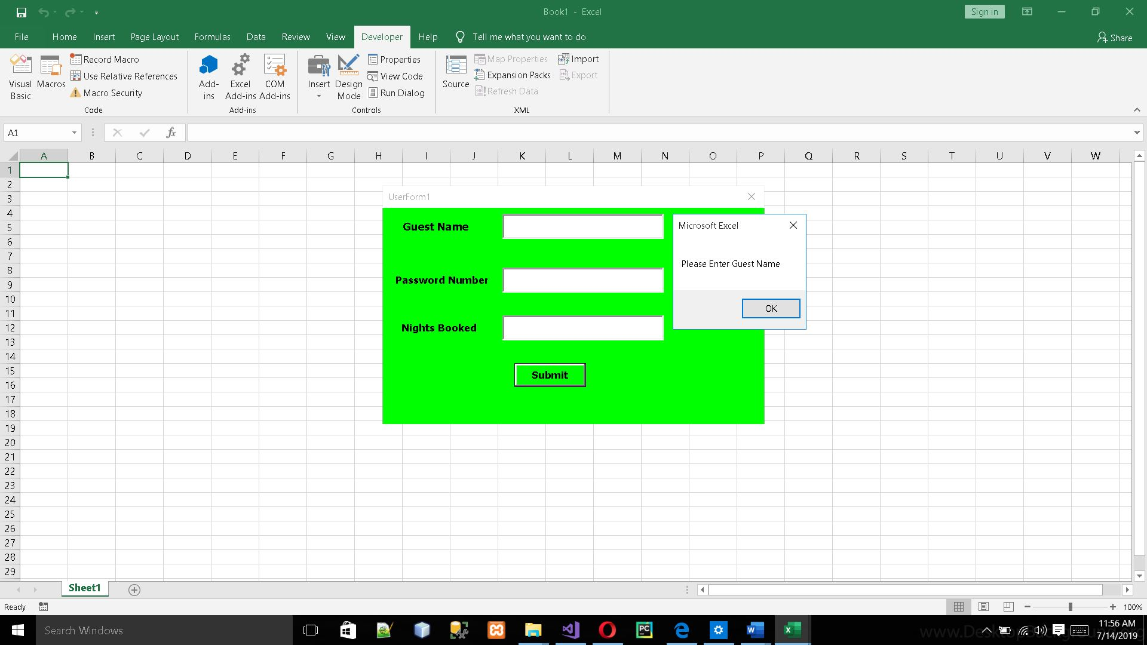

Figure 8 : Request Showing Guest Name

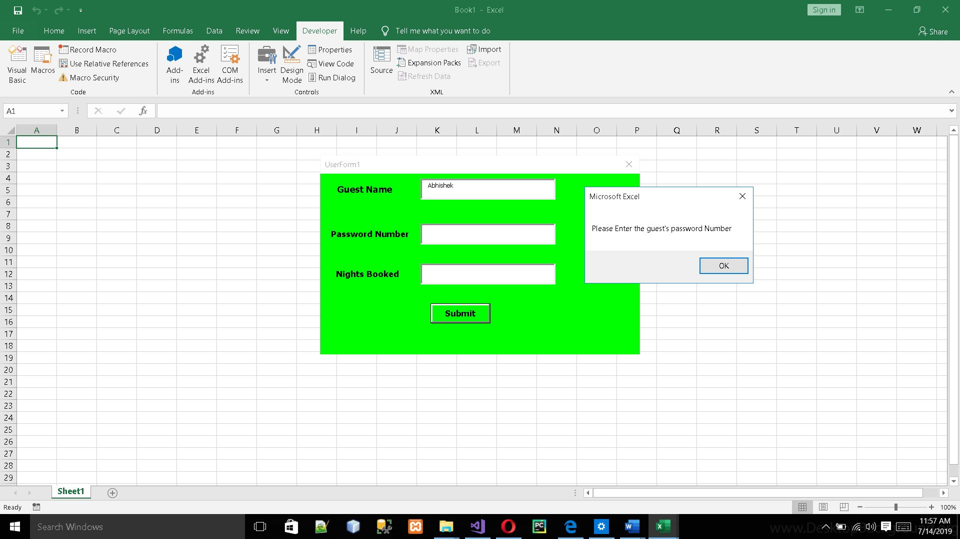

Figure 9 : Request Showing Guest Password Number

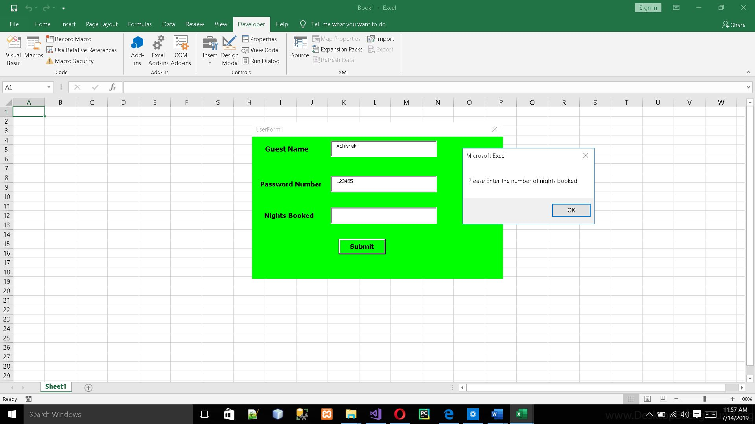

Figure 10 : Request Showing number of nights booked

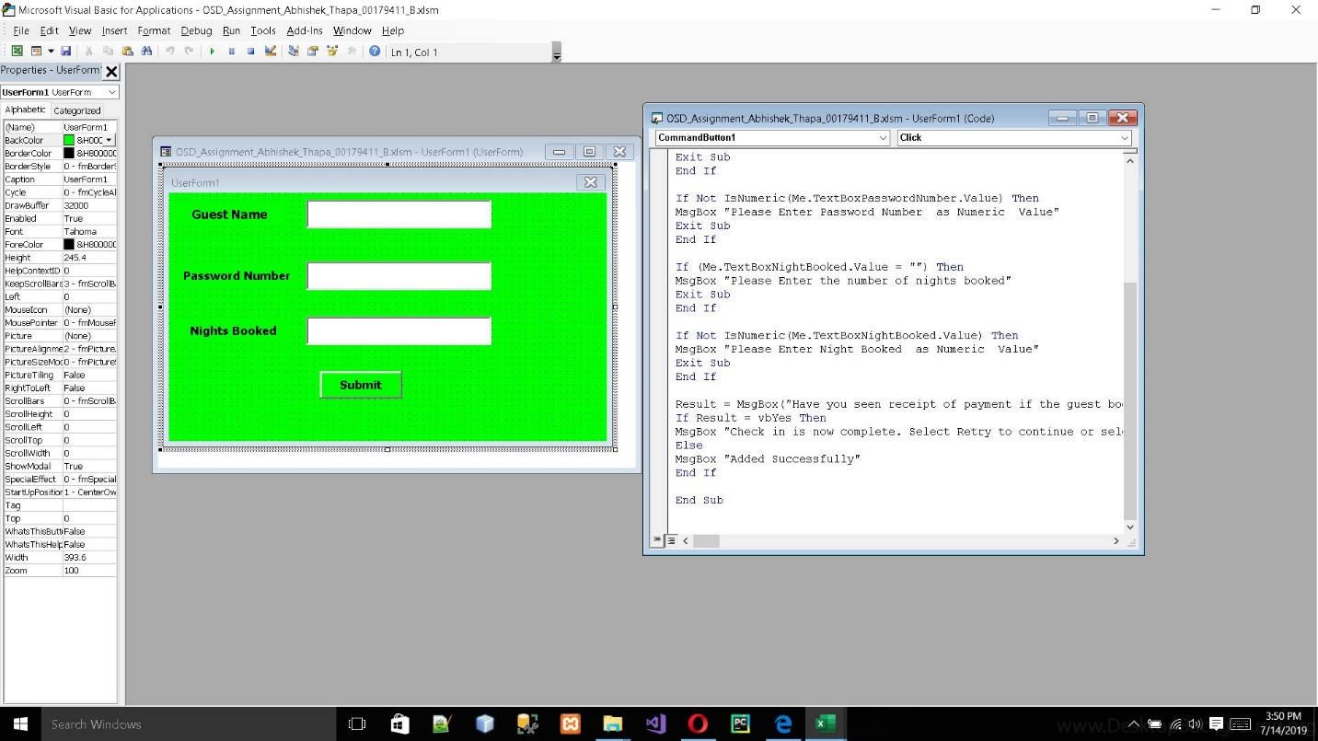

Figure : Coding of task b

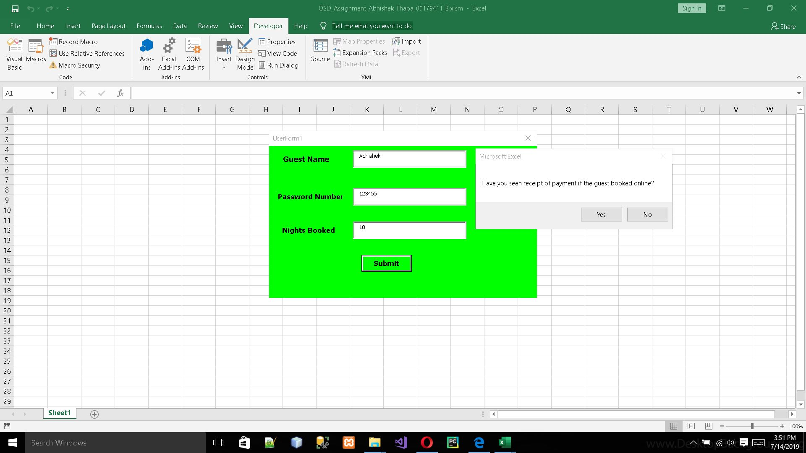

Figure : Message Box displaying

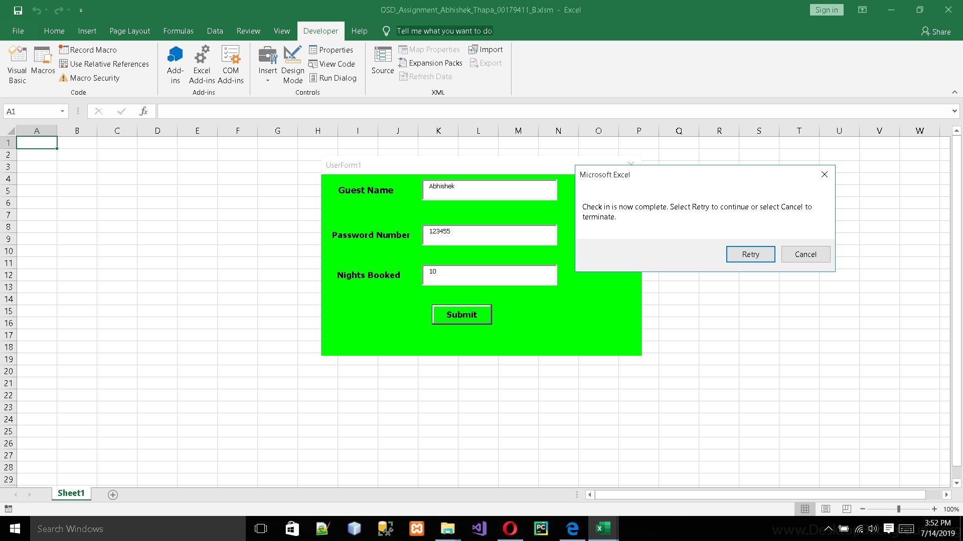

Figure : Command in the Message Box